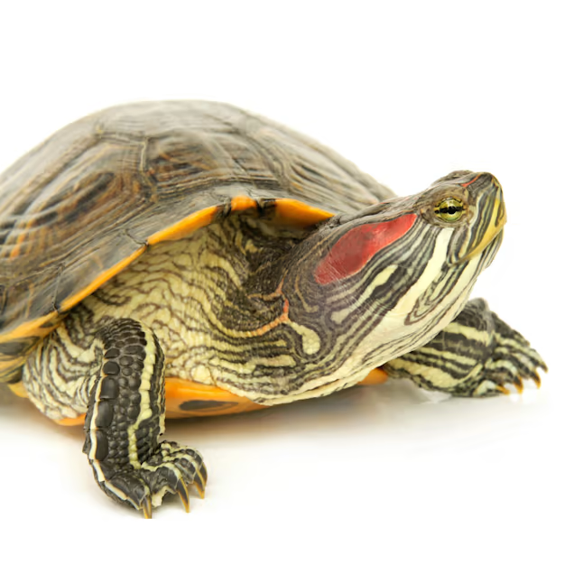
Husbandry, Red Eared Sliders
Natural Habitat
Red-eared sliders (Trachemys scripta elegans) are native to the United States, with a normal range from Illinois to the Gulf of Mexico, and from the East Coast to western Texas. In their natural habitat, red-eared sliders are freshwater turtles that prefer ponds, marshes, and slow-moving water, even though they are strong underwater swimmers. Sliders prefer to spend most of the day sunning themselves on rocks that project out of the water and foraging for food, then retreating to the bottom of the pool to spend the night.

Housing
In captivity, red-eared sliders need a warm, dry area and a large pool of warm water. Red-eared sliders should be maintained in at least a 30- to 50-gallon tank that has both a pool and an area for the turtle to crawl out and keep warm and dry. The water must be at least 1.5 to 2 times the turtle's total length in depth, with several extra inches of air space between the surface of the water and the top edge of the tank, to prevent escapes. You must make sure on a daily basis that the water is properly filtered and is free of all debris and waste material. Make sure that your water filter is working correctly because you need to keep the water clean, given that this species of turtle produces a lot of feces. Submersible filters seem to work best for red-eared sliders. Live plants can be added to the tank and will help to remove some of the nitrate wastes; however, your turtle might eat the plants. Do not use small stones on the bottom of the enclosure because your turtle can swallow them and may get sick as a result.

Red-eared sliders require exposure to ultraviolet (UV)B light as an essential part of maintaining calcium balance in their bodies. UVB-producing lights, which can be purchased at your local pet store, need to be changed approximately once every 12 months. We generally recommend products from the ZooMed Company. You can see these products on the Internet at www.zoomed.com. Plastic and glass screens can filter out UVB rays and should not be interposed between the lamp and your turtle because the turtle needs the UVB rays to fix the calcium on its bones and shell. The UVB light should not be farther than 12 inches away from your turtle. We recommend a 12-hour light/dark cycle, so that your slider receives UVB for at least 12 hours a day.
Temperature
Red-eared sliders are ectothermic, meaning that they rely on their environment to regulate their temperature. For red-eared sliders, water temperature should be kept between 75°F and 85°F, and the basking area temperature should be about 85°F to 95°F. All temperatures should be monitored with the use of thermometers.
Diet
Red-eared sliders are omnivores in the wild, meaning that they eat both animal protein and vegetable/plant matter. It is important to remember, however, that adults eat less animal protein and more vegetables than juveniles. A combination of the following foods should be fed: commercial diets (no more than 25% of total diet) such as trout chow and reptile or turtle food; animal protein (no more than 25% of total); and plant matter (50% or more of diet) such as dark leafy greens (collard, mustard, and dandelion greens), shredded carrots, squash, green beans, apples, melons, and berries. Vitamin supplements may be given but should not be necessary provided the diet is adequate and balanced. Good commercial food sources are Reptimin sticks by Tetra or similar food sticks produced by Wardley, or Mazuri turtle food. All of these foods are available in good pet stores.

Handling
Red-eared sliders should be allowed to acclimate to their new enclosure before attempts are made to handle them. Getting a new home is very stressful for turtles, so give them a few days to get used to their environment before trying to pick them up. Red-eared sliders need to be supported from underneath; it is best to use two hands so that they feel more secure. When holding your turtle, do not just support the plastron (bottom shell); make sure to support the legs as well (it is very stressful for them to feel nothing beneath them).

Behavior
Red-eared sliders prefer to spend most of the day basking or foraging for food; at night, they will retreat to the bottom of their enclosure to rest. Most prefer to have a basking site that is projecting out of the water like an island; lamps should be placed above these islands to provide the turtle with heat and UVB exposure. Red-eared sliders generally will get along, if more than one turtle is desired; however, you must keep in mind that two turtles require an extremely large enclosure, so make sure that you have enough space for an additional turtle before purchasing one.

Lifespan
Red-eared sliders have a lifespan of approximately 25 years (15 to 50+ years).

Common Medical Conditions
Aural abscess. Ear abscesses (aka aural abscesses) are common in turtles and usually are caused by bacterial infection. The infection originates in the mouth and ascends up into the ear canal via the Eustachian tube. Turtles do not have an open external ear canal, so when infection reaches the ear, it accumulates as a large pocket of pus. This pus becomes firm and hardened and will not drain back into the oral cavity. Pressure from the growing abscess may cause hardened pus to rupture externally (through the tympanic membrane) or may create a large swelling. If the abscess does rupture, the firmness of the excretion does not allow for adequate drainage and will cause the abscess to persist. Eventually, changes to the skull can occur and may result in permanent damage. See your veterinarian if you notice signs of swelling behind your turtle's eye(s).
Hypovitaminosis A (or vitamin A deficiency). This disorder commonly affects aquatic turtles fed diets of greens, meat, and incorrectly formulated commercial diets without vitamin A supplementation. Some of the most common signs of vitamin A deficiency are swollen eyes (which do not respond to eye drops), nasal discharge, anorexia, and poor growth (because they cannot see). See your veterinarian if you notice these signs in your pet.
Parasites. Red-eared sliders can become infested with various types of parasites; your veterinarian can perform a fecal examination to detect these and can treat your turtle with an appropriate deworming agent.
Metabolic bone disease (MBD). If red-eared sliders are fed an inappropriate diet that is too high in protein (organ meat, krill, pure muscle) and deficient in calcium, they can develop metabolic bone disease. Signs of MBD are stunting, deformed shells (too soft or with pyramiding), and general lethargy and fatigue. You should make sure that you are providing adequate UVB exposure for your turtle. See your veterinarian for advice on how to correct the diet.
Many detailed sources of information on caring for red-eared sliders can be found on the website www.anapsid.org. We encourage you to use these to learn more about how to care for your new pet.

AUTHOR: Samantha Keat

